EXPERIMENT-9

AIM:
To create a snapshot of a virtual machine (VM) using Oracle VirtualBox, restore it to a previous state, and verify the functionality of the cloned VM.

Procedure:
- Start VirtualBox:
Launch Oracle VirtualBox on your host machine.
- Select the VM:
Choose the VM for which you want to create a snapshot.
- Take Snapshot:
  - Go to Machine → Take Snapshot or click on the Snapshot icon.
  - Enter a name (e.g., “BeforeUpdate”) and optional description.
  - Click OK to save the snapshot.
- Modify the VM (Optional):
  - Make changes in the VM (install software, change configuration, etc.) for testing.
- Restore Snapshot:
  - Power off the VM (if running).
  - Go to Snapshots Tab.
  - Select the saved snapshot and click Restore.
  - Confirm the restoration.
- Clone VM (Optional Testing):
  - Right-click the VM → Clone.
  - Choose Full Clone or Linked Clone.
  - Name the cloned VM and finish the cloning process.

- Start the Restored or Cloned VM:
  - Run the VM and verify it has reverted to the snapshot state.

Successfully created a snapshot of the VM, restored it to its previous state, and verified functionality by running the restored/cloned VM without any errors or data corruption.
STEP 1:
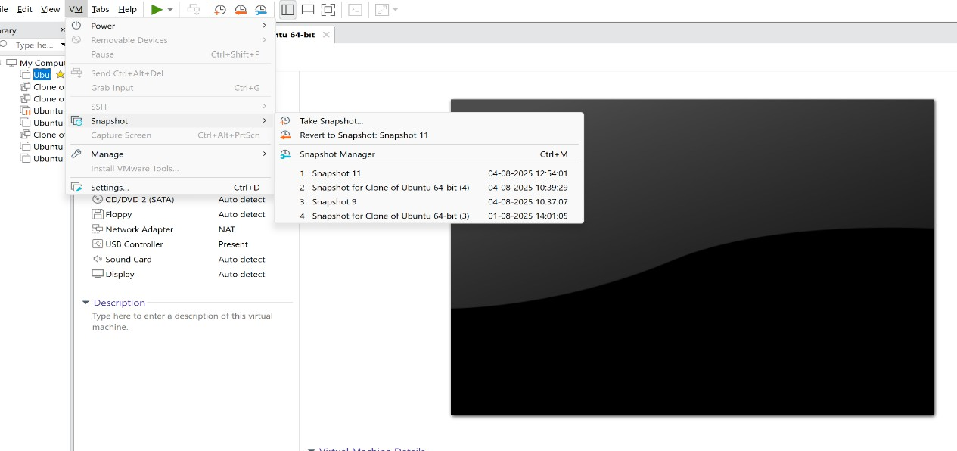
STEP 2:
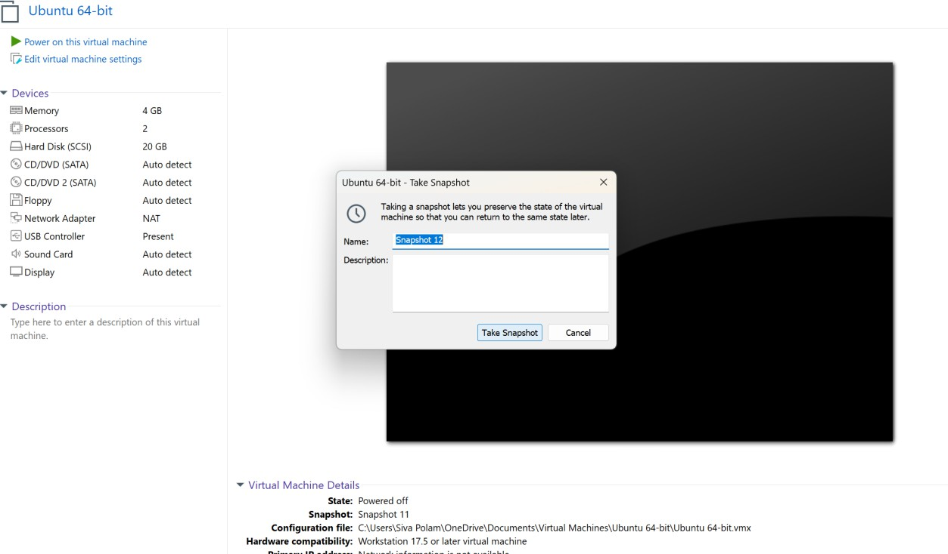

STEP 3:

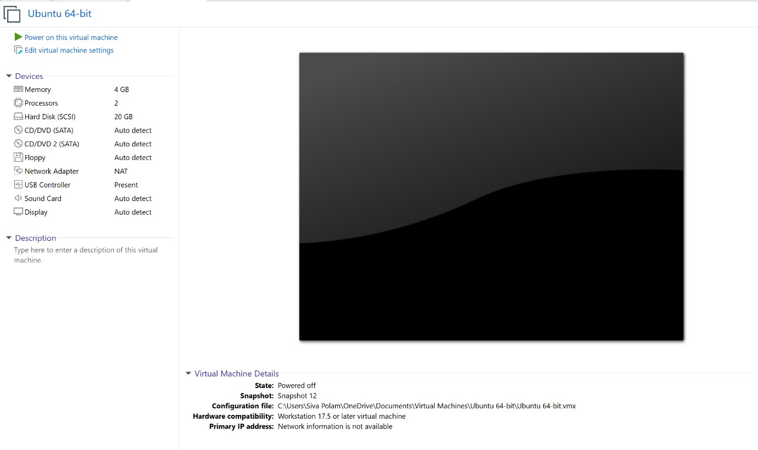

Result:
Successfully created a snapshot of the VM, restored it to its previous state, and verified functionality by running the restored/cloned VM without any errors or data corruption.

